# **Component -2**

|  |
| --- |
| Advanced Web EngineeringArbindra Kumar Sah 77229157 |

1. Migrating Table to database

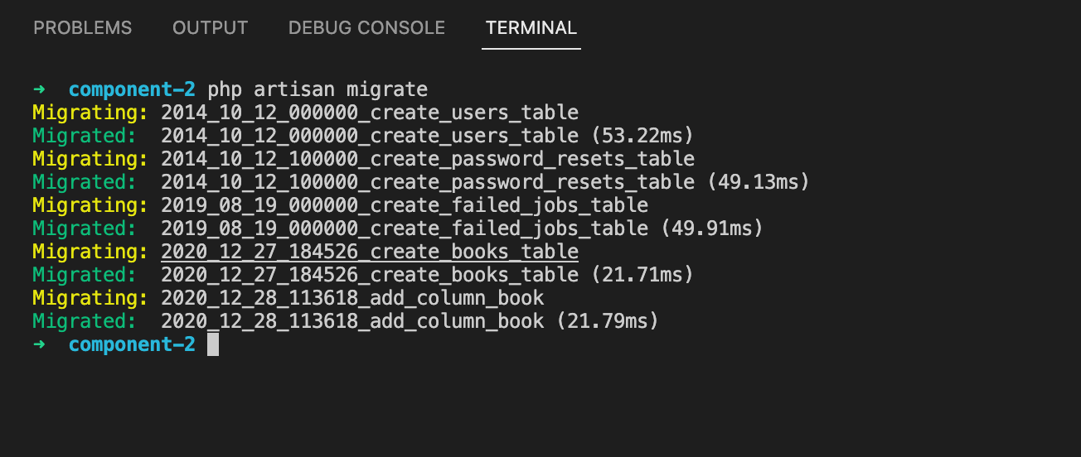

1. Creating database seed and Database seeding

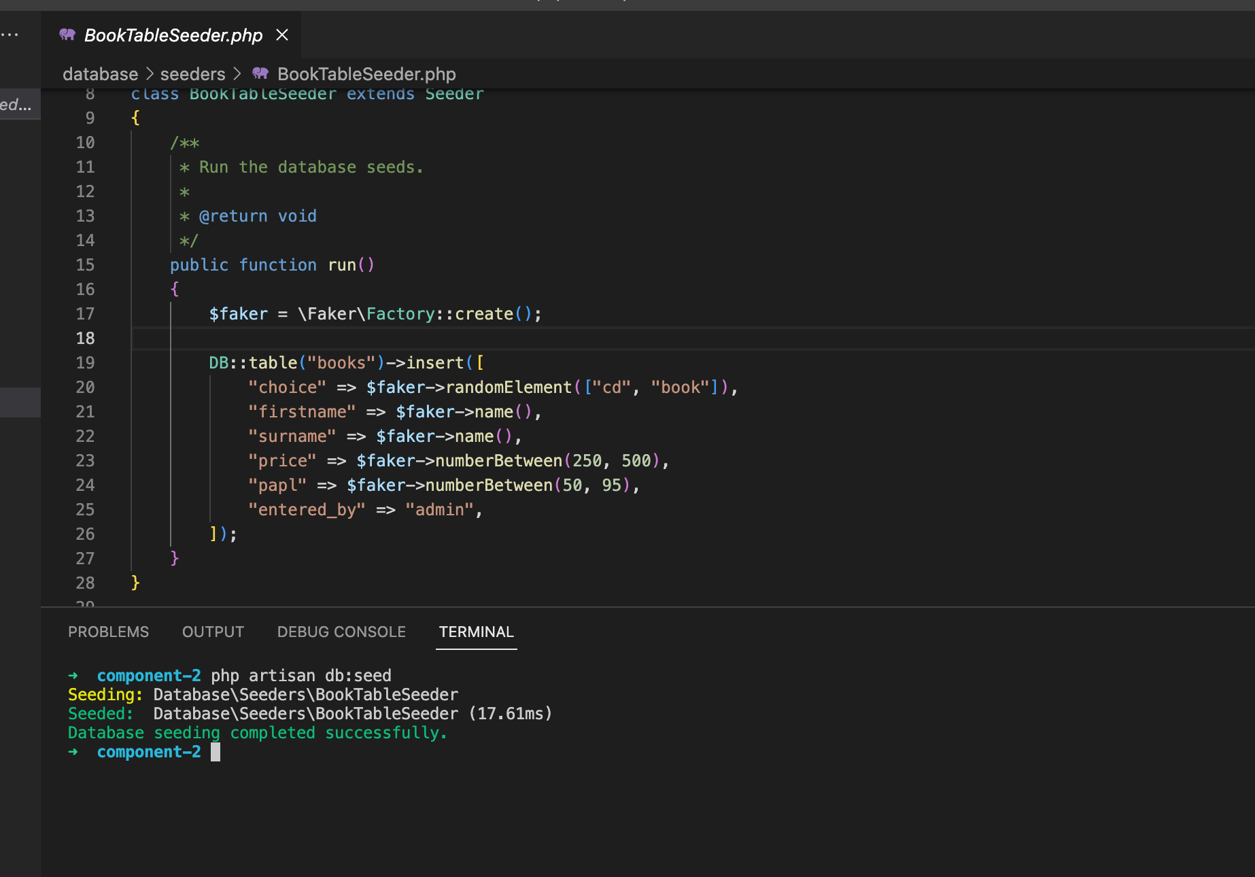

1. Table Created after migration and database seed

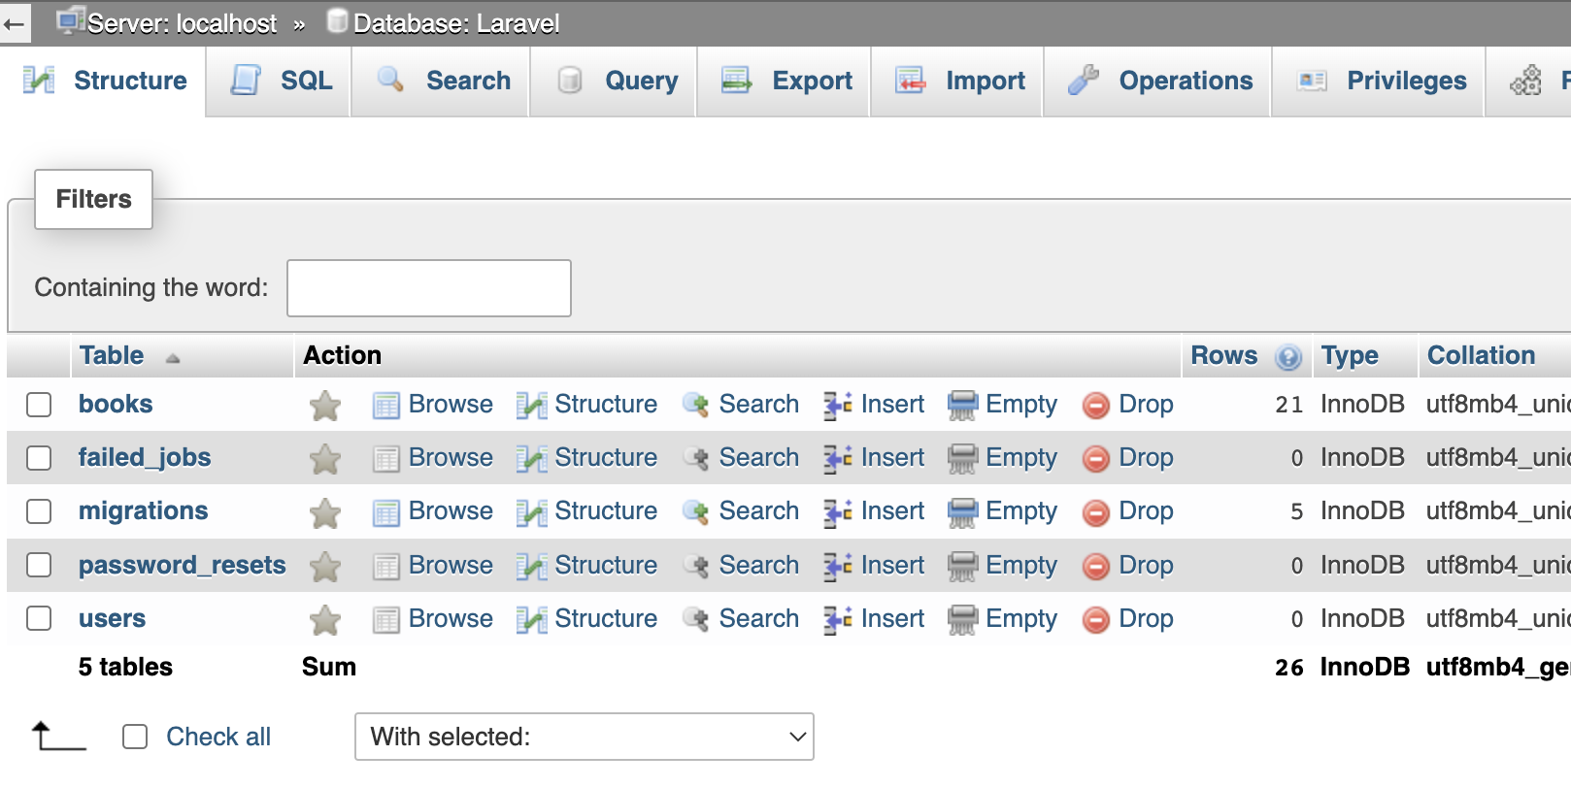

1. Laravel Home

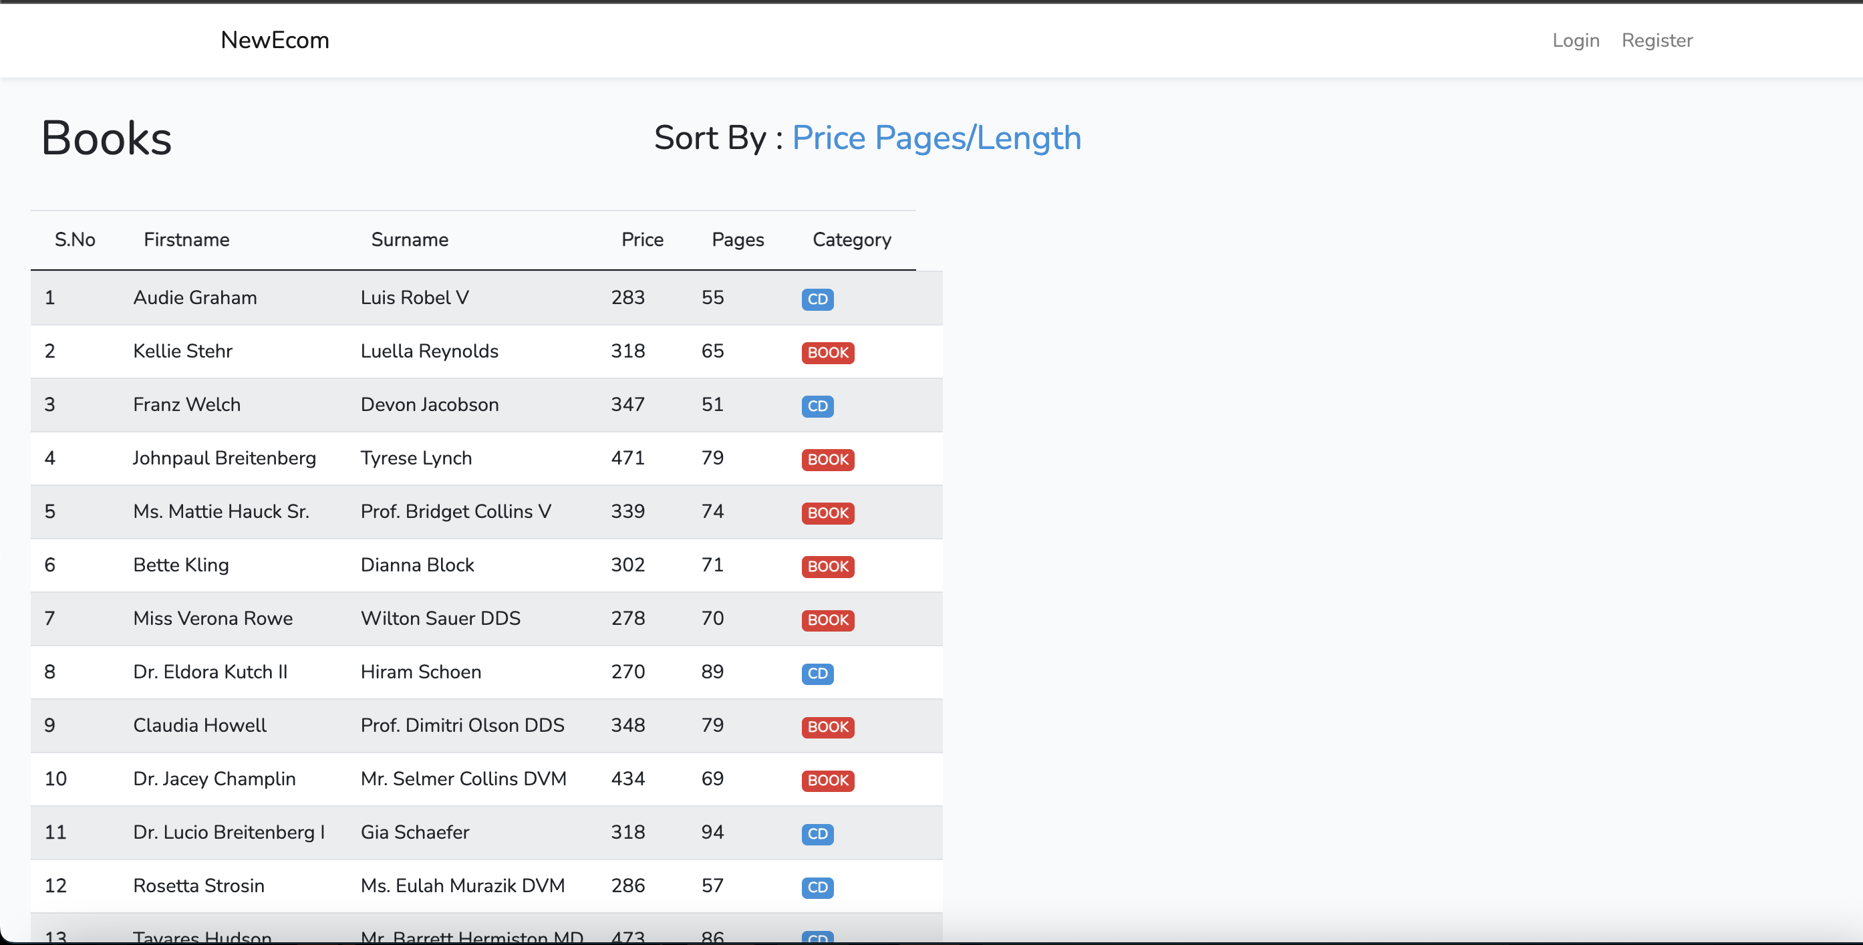

1. Registering user

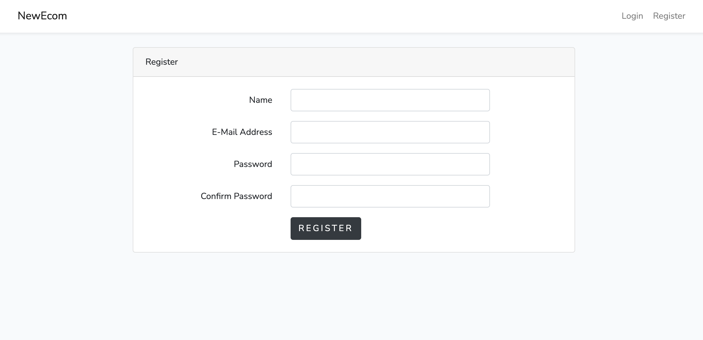

Register successful

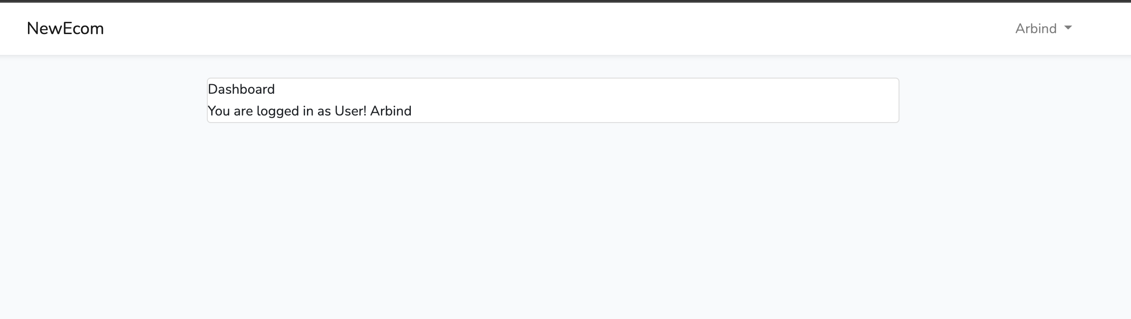

1. Logging in

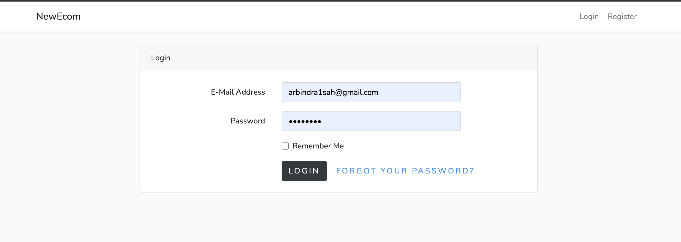

1. Dashboard

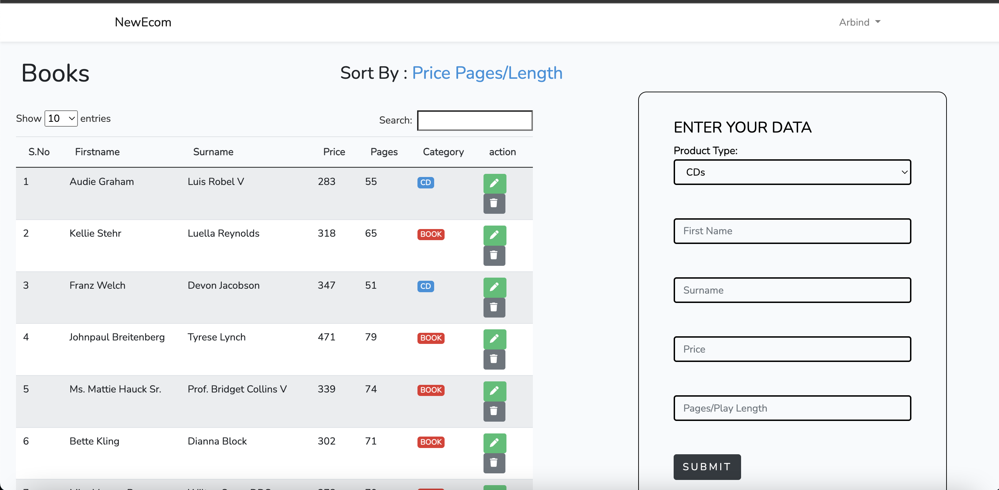

1. Entering Product

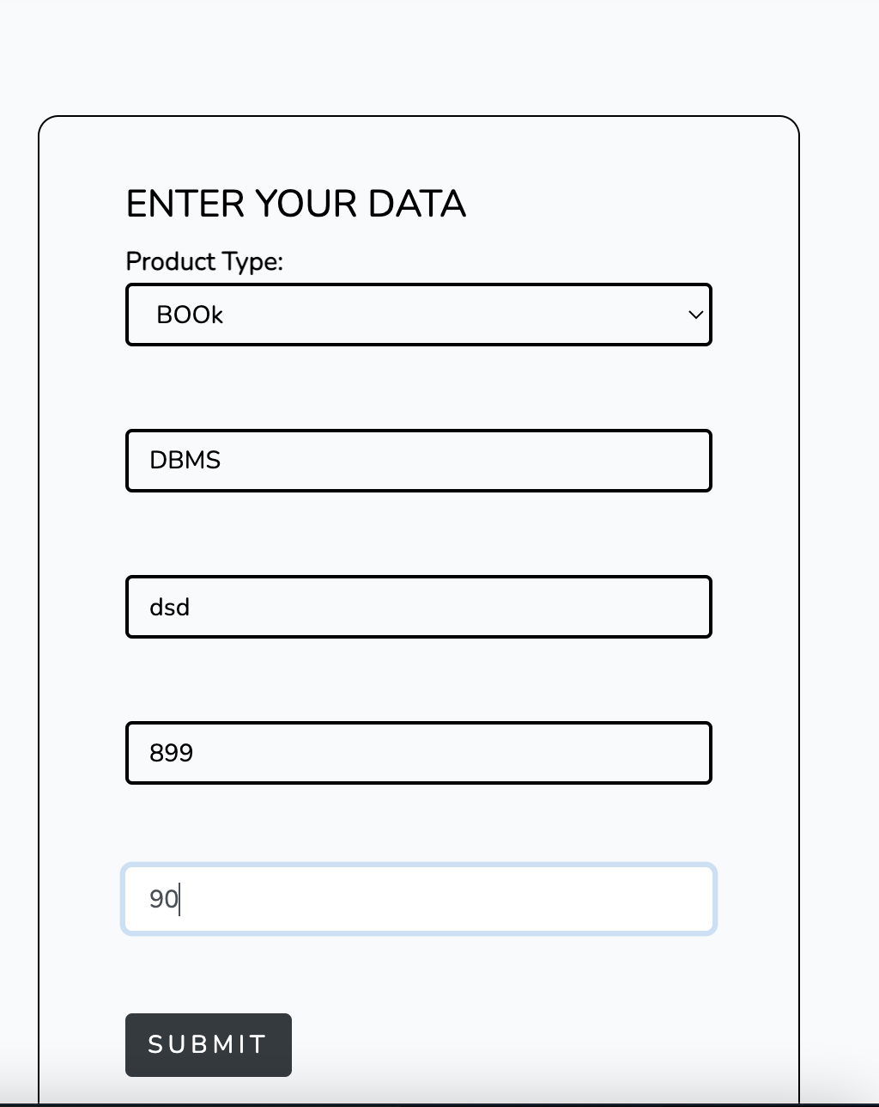

Successfully Product Entered

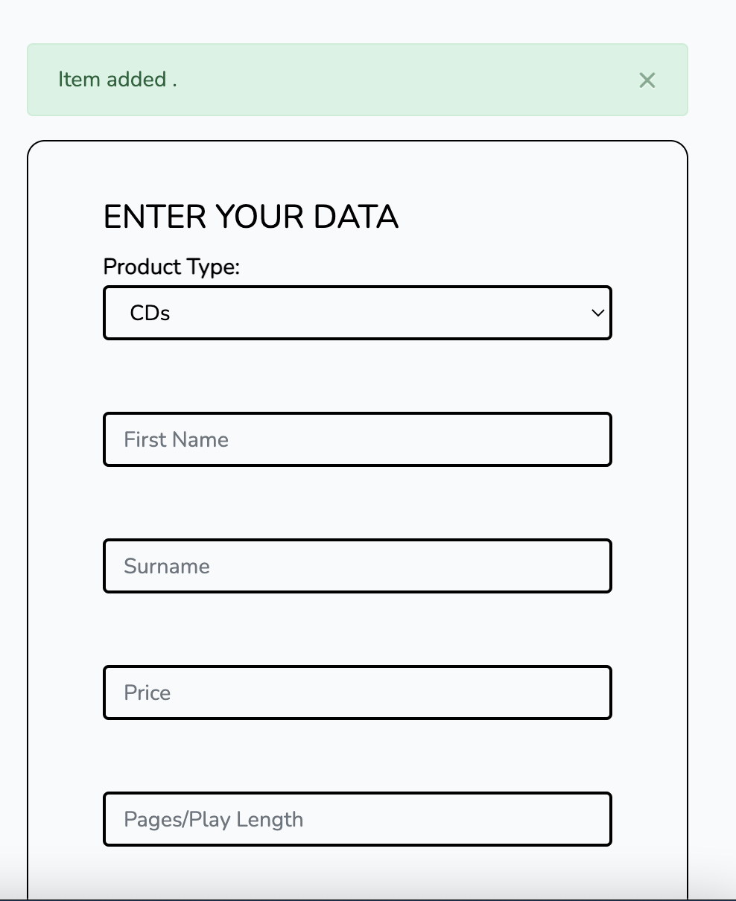

1. Updating product by admin

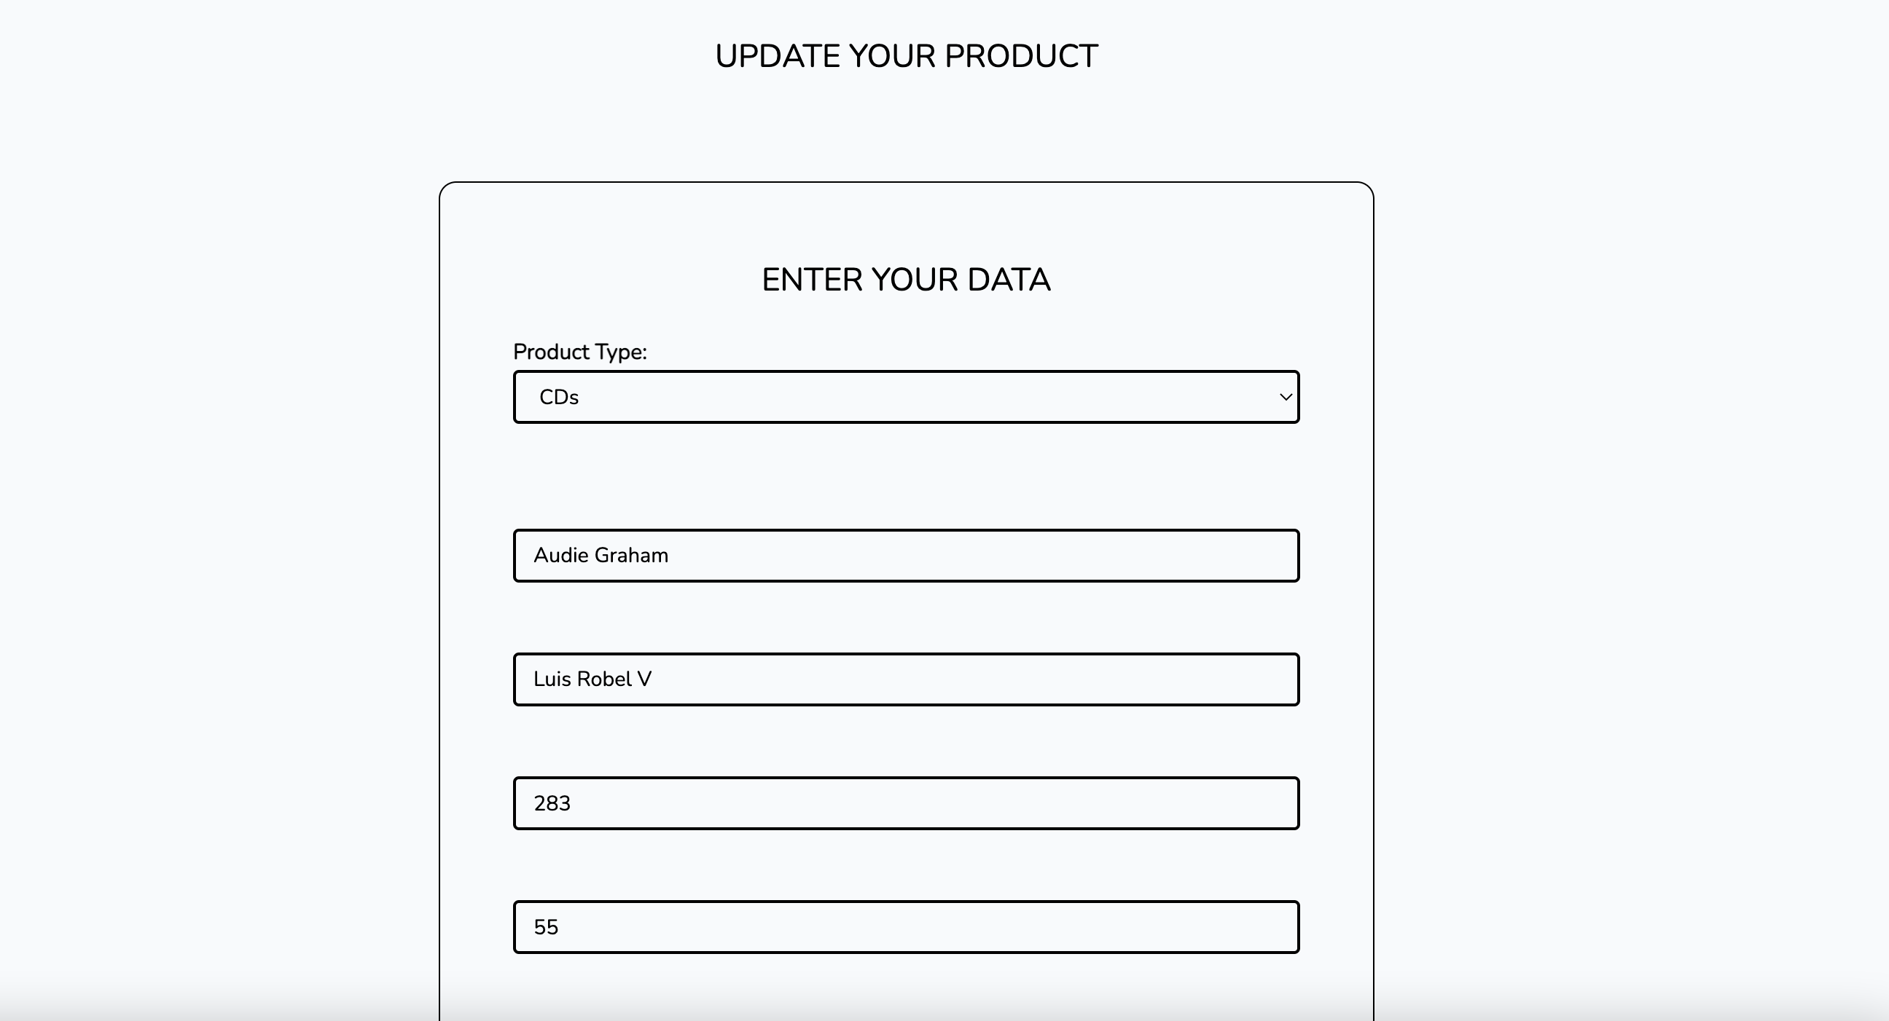

Successfully product updated

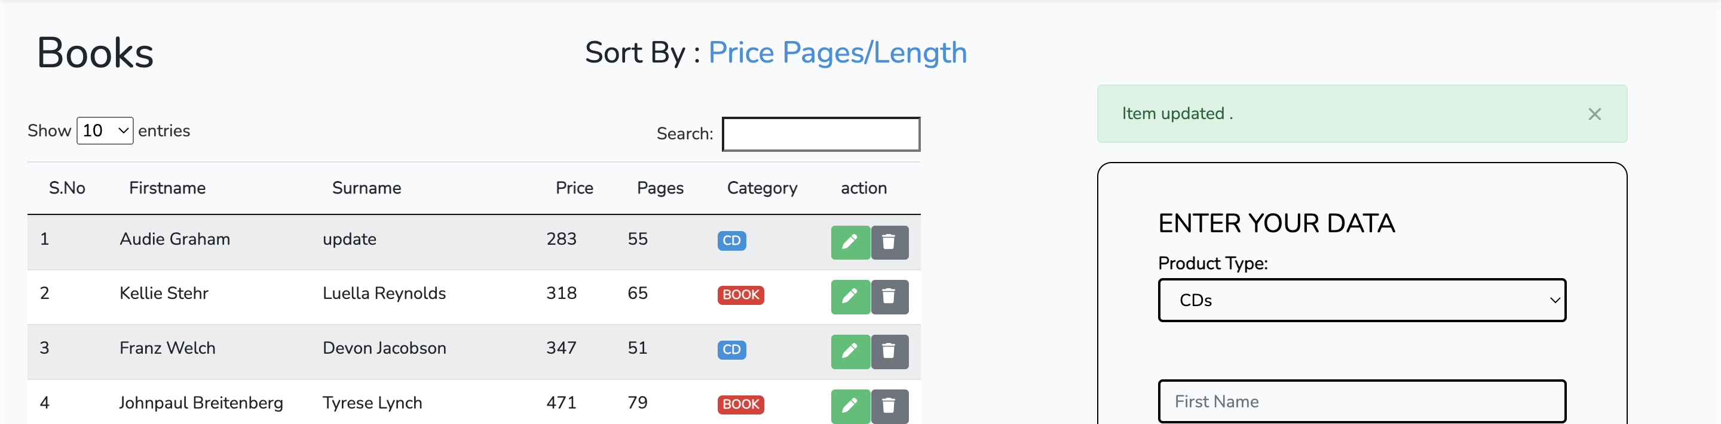

1. Deleting product

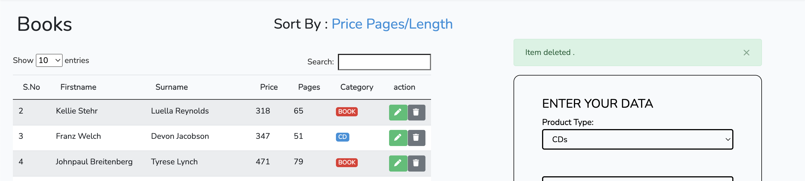

Product Deleted Successfully

1. YouTube video tutorial link